

MedCommons – A Patient-Centric ExoSkeleton for the NHIN

The interconnection of disparate healthcare enterprises into a cohesive NHIN is a large undertaking that is currently under evaluation and prototyping by the federal government [1]. MedCommons provides a lightweight means for adding patient-centric services to current generation PHR and EHR systems, Laboratory and Personal Medical Devices, RHIOs and the various putative NHIN prototype efforts.

MedCommons creates an exoskeleton over existing enterprise and personal IT systems by blending distributed patient health record storage, with simple, secure communications protocols for connecting legacy systems, and a flexible approach to managing patient Identity on a national scale. The exoskeleton grows incrementally yet independently of the NHIN by adding additional resources only as patient coverage increases.

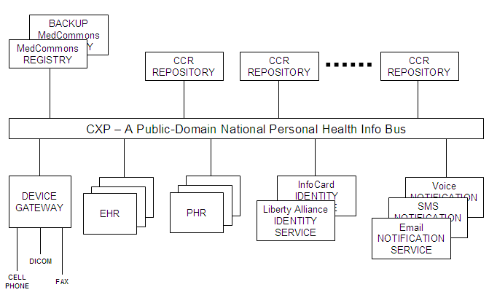

- Storage: Copying source content into a distributed document repository and a centralized registry keeps things simple, and builds confidence in the archival nature of the service. MedCommons is patient-centric because each patient has an account and maintains a collection of key documents and consents. Source content is left untouched, and is normally never referenced again by MedCommons, as at least one copy is maintained by the service in a document repository. Access to an account is strictly controlled, with notification alerts to the account holder every time the account is referenced.

- Communications: The primary means for inserting and retrieving documents is the Commons Exchange Protocol, or CXP, which is an open WS-* based standard sponsored by the CCR Accelerator Group [2]. Third party PHR, EHR and device vendors utilize CXP to send and receive CCRs and other XML formatted documents into accounts. To achieve interoperability between all parties, it is necessary to minimize the number of duplicative document types, but for now MedCommons will support CCRs, PDFs, DICOM, and whatever else the market demands.

- Identity: The techniques for identification of individuals are quite varied. At the simplest level, anyone can self-register for a plain MedCommons account with a username and password and an optional two-factor cell phone identity check. At the other end of the spectrum, MedCommons supports federated identity management systems from Liberty Alliance and will ultimately support Microsoft InfoCard as well [3]. Federated identity allows large enterprises to participate in Single Sign-On with MedCommons, as well as dynamically securing the CXP protocols. With federation, it is possible to integrate large communities of patients such as RHIOs directly into MedCommons.

- Notification: In a multi-enterprise environment, some of the responsibility for monitoring security will fall on the patient or clinician themselves. MedCommons integrates a lightweight email notification function that alerts the patient to changes in their account and to access of their information without divulging the information itself. This notification functionality can also serve as a means of contacting a patient to request informed consent to a disclosure that otherwise would not be covered by HIPAA direct patient care regulations.

The MedCommons Family of Services

The exoskeleton is both a platform for the NHIN and a useful point-to-point transport medium unto itself, capable of providing useful, patient-centric, cost reducing, quality improving value right now, well in advance of the formulation of the NHIN. The ecosystem consists of the Core MedCommons Service, and the MedCommons Partner Systems and Services.

Core MedCommons Service

The operational MedCommons service, at http://medcommons.net/ consists of a pair of replicated MedCommons Document Registries and a scaleable collection of application servers at two diversely situated data centers, and a widely distributed collection of MedCommons Document Repositories in both these locations and also in partner and select customer locations, The service ensures that multiple separately encrypted copies of all documents are maintained by MedCommons according to patient account preferences for both backup and performance purposes.

A small re-brandable AJAX-based user interface is offered as part of the MedCommons service to allow access to the patient’s account, to view any previously stored content, to send and receive secure healthcare communications, and to control access to her personal health information by healthcare providers. A similar interface is available to healthcare providers to display a restricted view of patient content. But MedCommons is not in the user interface business. Instead, the primary means for access to MedCommons content is via the user interfaces of the PHR and EHR systems, enterprise portals, and other 3rd party configurations via CXP and additional MedCommons specific web services.

Optional DICOM support for radiology and cardiology is offered as part of the MedCommons service for owners of DICOM devices and PACS systems that wish to utilize MedCommons directly from within their existing workstation vendor environment. A standard feature of MedCommons for all users is a web-based, FDA approved, AJAX display of DICOM content with easy to use tools for image manipulation. However, long term DICOM storage in MedCommons Repositories is a premium feature.

Optional FAX mailboxes may be established for any MedCommons account. This allows the patient to distribute a fax number for his healthcare providers to supply source documents if there is no other direct means. The Faxes are rendered as PDF documents for archival storage.

Optional re-brandable Mobile Device support will allow appropriately configured cell phones and PDAs to collect personal healthcare data on a periodic basis and automatically integrate into a MedCommons account.

Partner Systems and Services

The attraction and efficacy of a common ecosystem depends largely on the ease of integration. Most third party software integrates with MedCommons via CXP and standard web service protocols. The storage model for different types of partners can vary: For some single user systems such as a PHR the MedCommons Account might be considered the primary repository for healthcare content. Multi-patient systems such as an EHR or Practice Management System will typically consider MedCommons as a secondary store, and require an explicit “Export” from the application. Lab and personal mobile devices will typically utilize CXP in a message push mode, to upload values into a patient’s account at the completion of some workflow event that is managed separately from MedCommons.

Enterprise Portals can integrate with MedCommons via MedCommons JSR-168 supplied portlets, or CXP can be incorporated directly into the portal. Many portals will also include a third party Identity System for Single Sign-On within the Enterprise and MedCommons (via Liberty Alliance or Microsoft InfoCard), and for securing MedCommons web service communications within the enterprise user community.

RHIOs integrate with MedCommons by incorporating CXP based applications such as EHRs, PHRs, into their networks, and by utilizing a Federated Identity Service to establish MedCommons Accounts for patients and providers.

All MedCommons Partners are presumed to run their own direct customer support call centers, with a 2nd tier help desk and case repository provided via at http://medcommons.net/?p=support

Built-in MedCommons Applications

There are three inbuilt MedCommons Applications that are available to all patients directly from www.medcommons.net or through a PHR or EHR system

- Free Emergency CCR Service – allows any user to manage and carry a wallet card to provide immediate access to critical emergency healthcare information from any Emergency Room. The card can also be branded and printed by any partner PHR or EHR system.
- Free Commons Service – allows any document to be anonymously and temporarily stored within MedCommons, for access by any PHR or EHR system via CXP. Within thirty days, documents must be moved to a patient account, or are permanently deleted.
- Paid Accounts Service – subscription based accounts holding a lifetime of personal medical content, including complex content such as DICOM, laboratory device reports, optional faxes. A set of MedCommons specific web services are available for management of accounts, including Single Sign-On, from PHR and EHR systems.

Conclusion

The MedCommons family of services combines distributed storage, standard protocols for document exchange, and federated identity management to produce a platform for support of next-generation, networked healthcare applications and communities including EHRs, PHRs, Enterprise Portals, RHIOs, and HMOs. This set of services forms a patient centric exoskeleton for the forthcoming NHIN, which can shape itself incrementally and evolve in advance any formal NHIN direction and without changes to existing privacy and consumer protection statutes.

